NAMA : Christoper Siahaan

NIM : 17051204056

TUGAS PEMROGRAMAN WEB

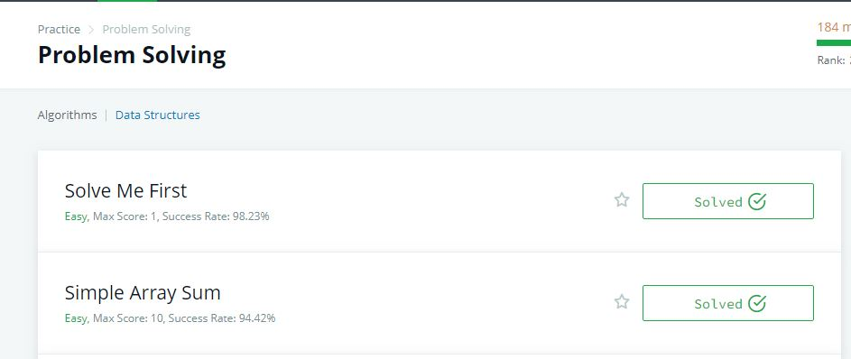1 . problem solving

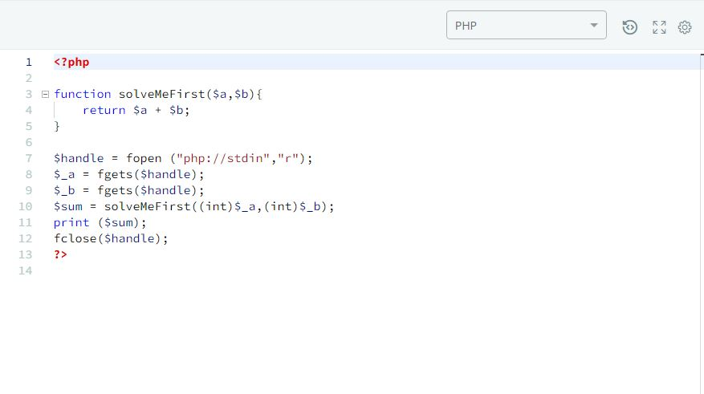2. Solve Me First

3. Simple Array Sum

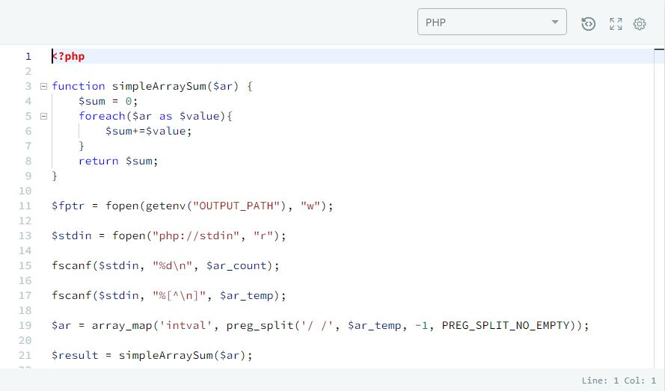

4. Compare The Triplets

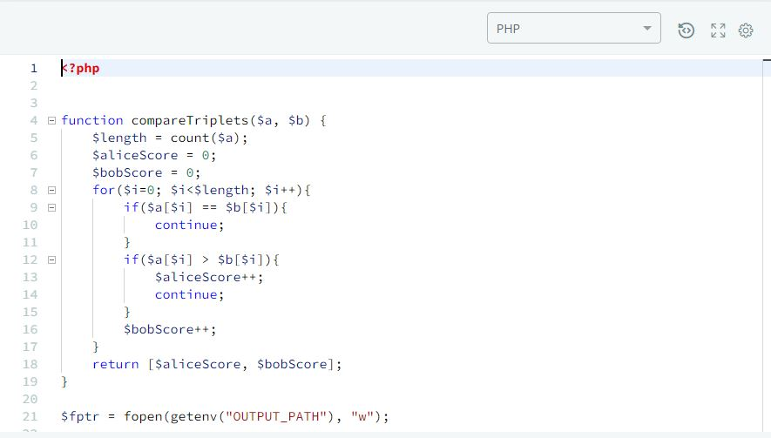

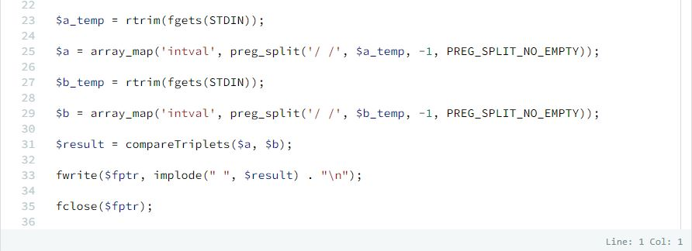

5. A Very Big Sum

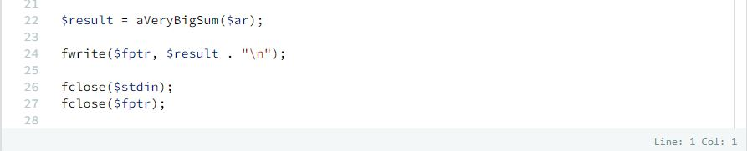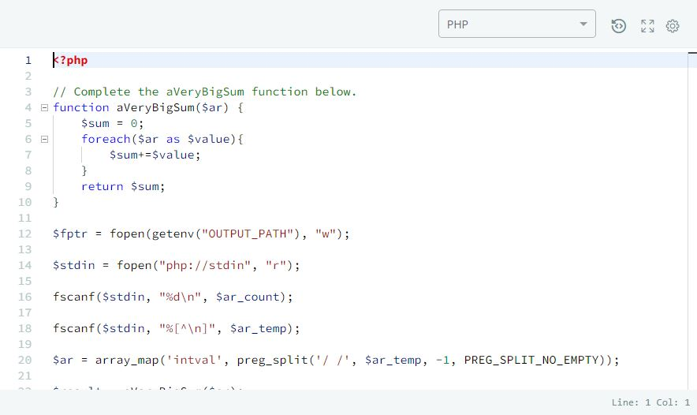

6. Diagonal Difference  
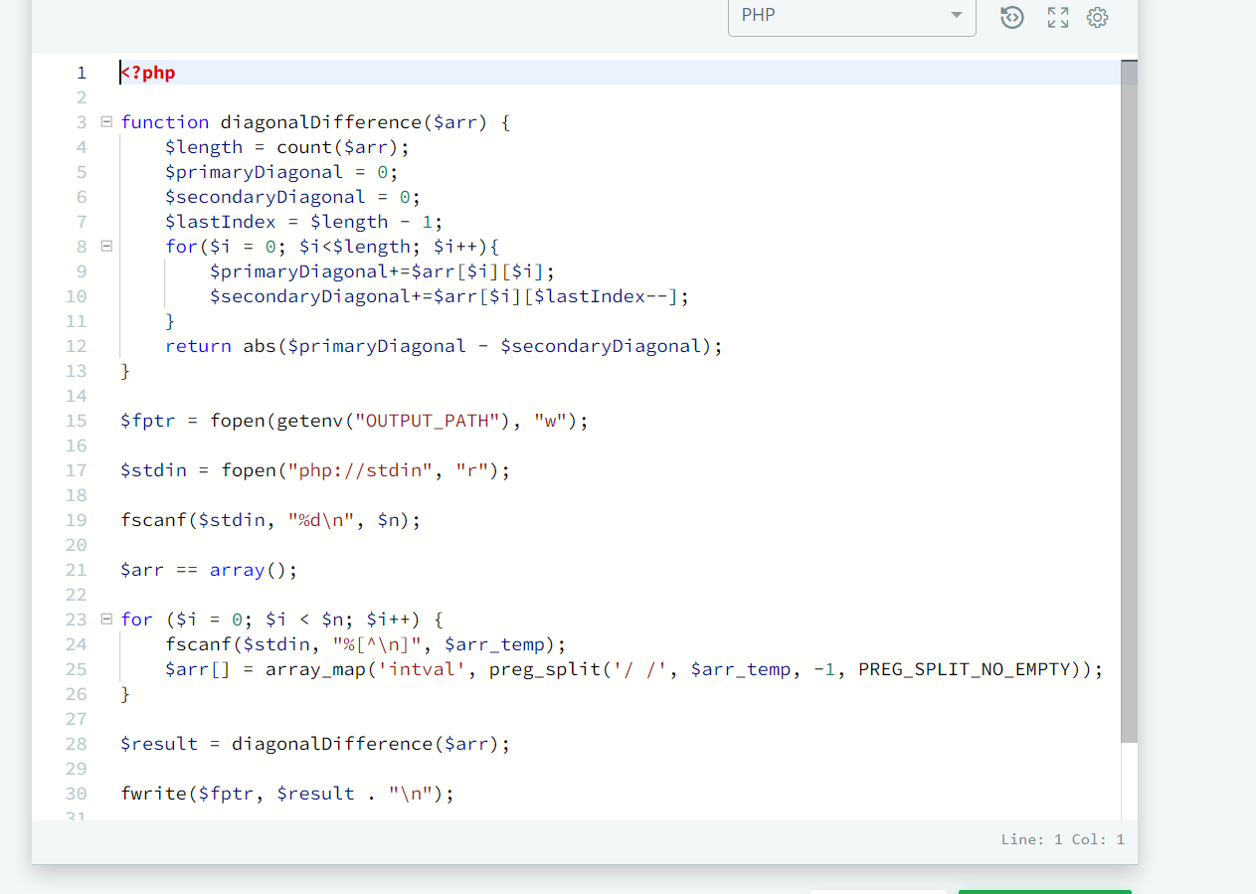

7. Plus Minus  
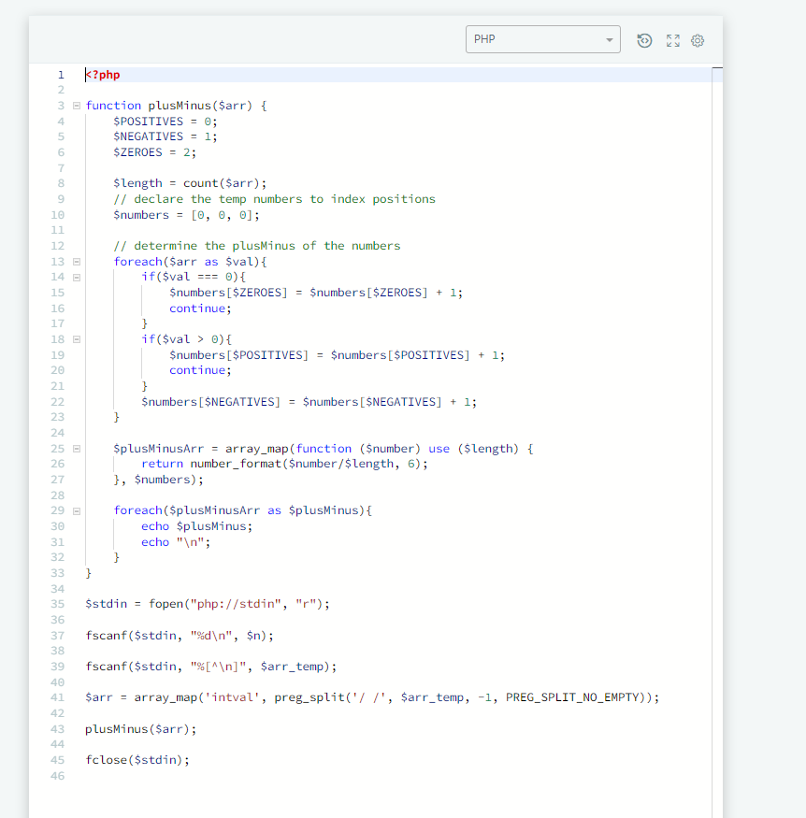

8. Staircase  
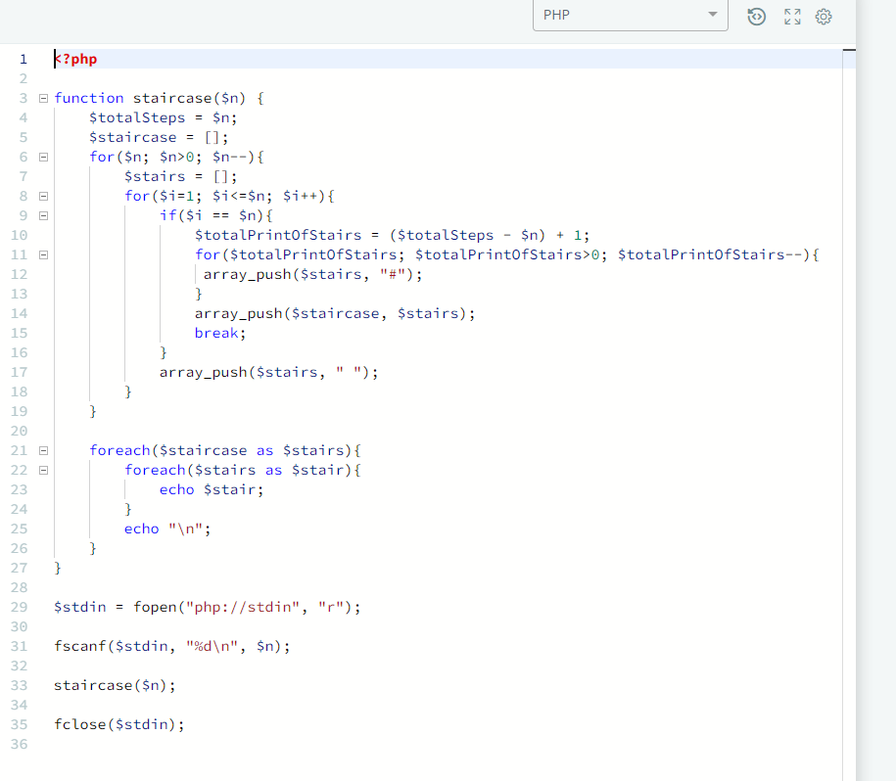

9. Mini-Max Sum  
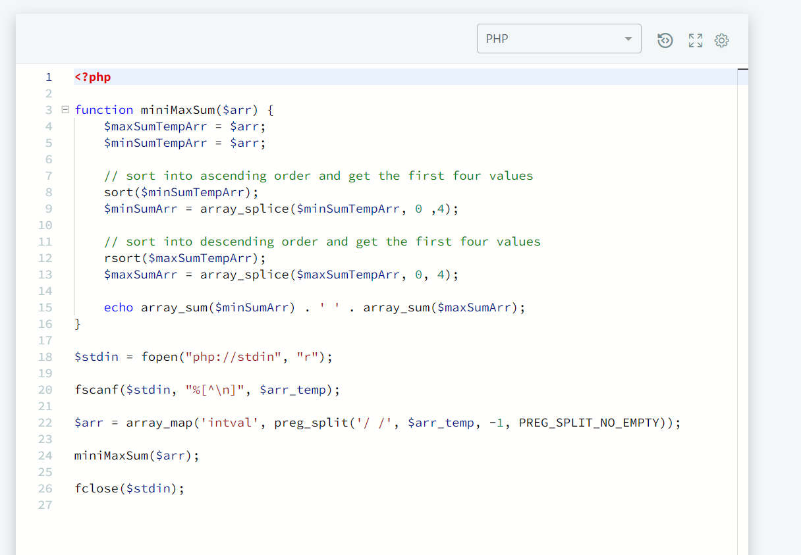  
  
10. Birthday Cake Candles  
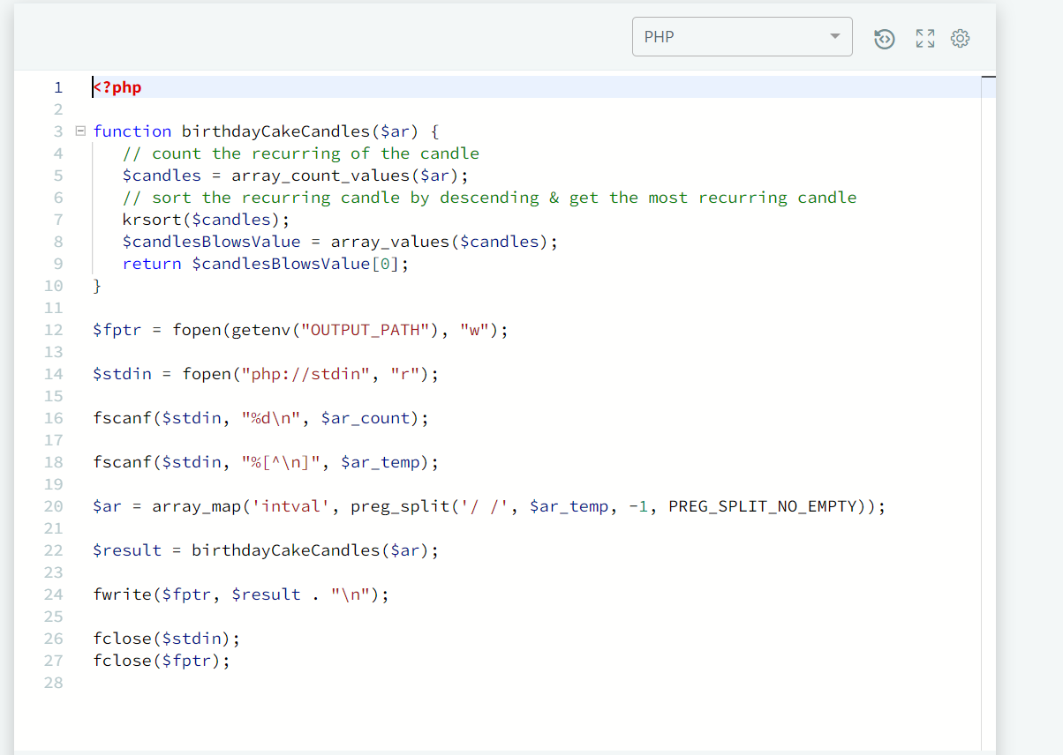  
  
11. Time Conversion  
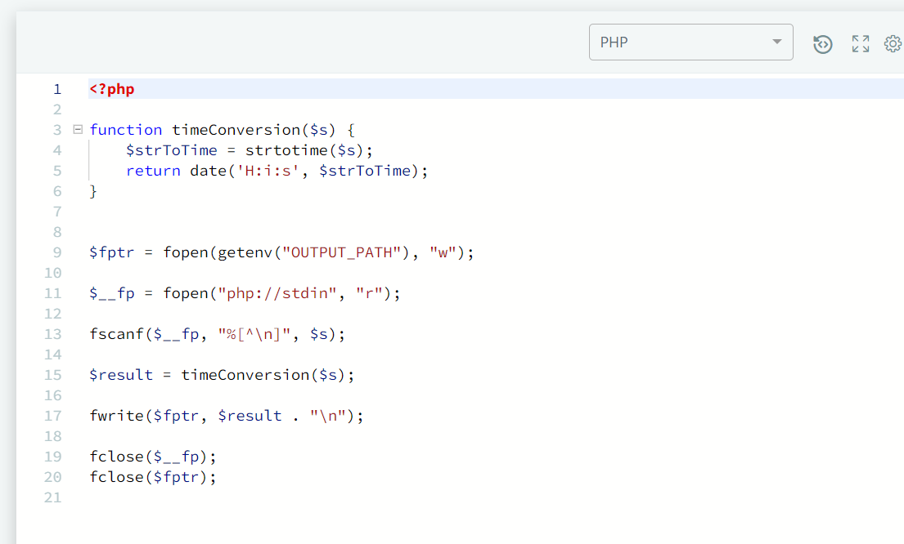  
  
  
  
  
12. Grading Students   
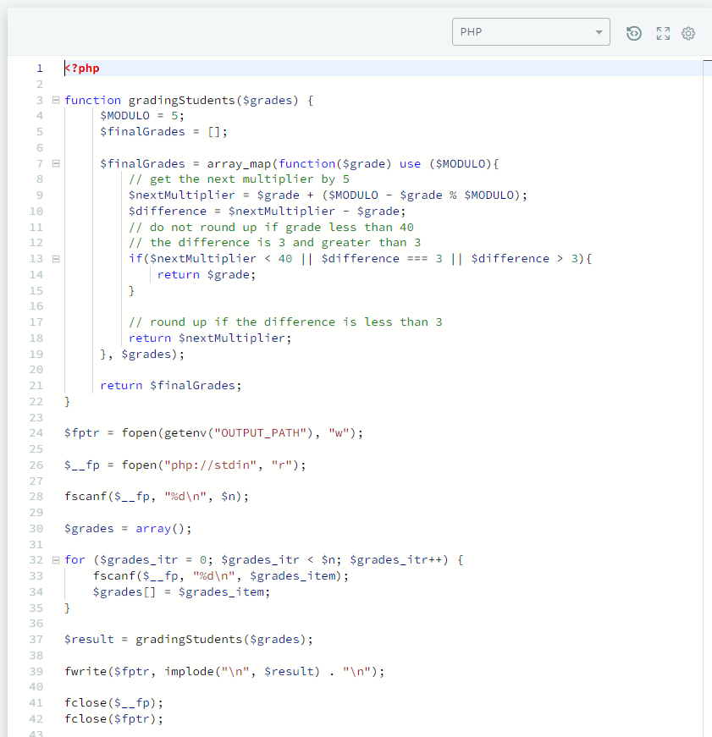  
  
13. Divisible Sum Pairs  
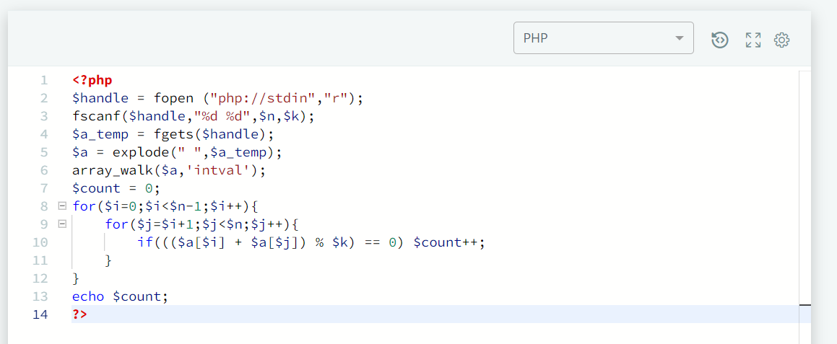  
  
14. Bon Appetit  
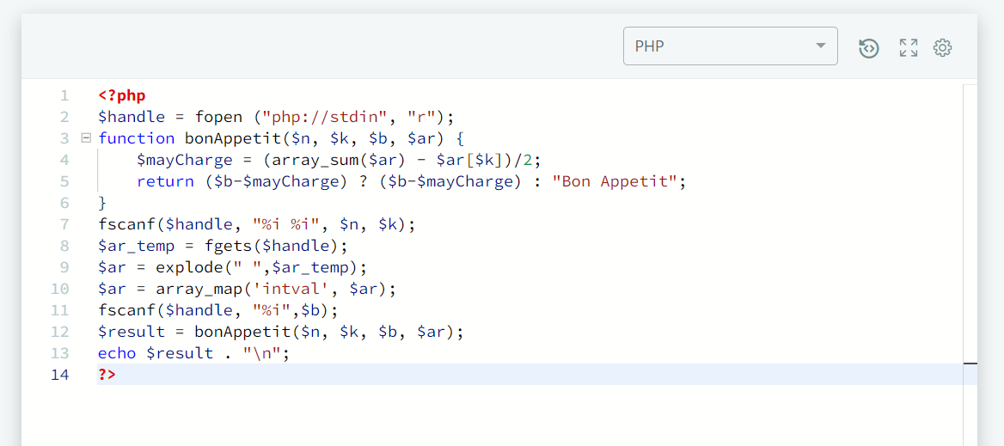  
  
15. Designer PDF Viewer  
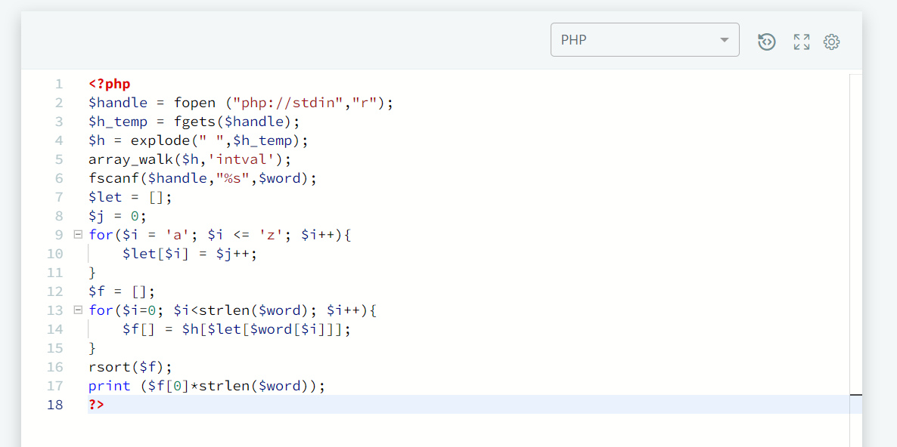  
  
16. Big Sorting  
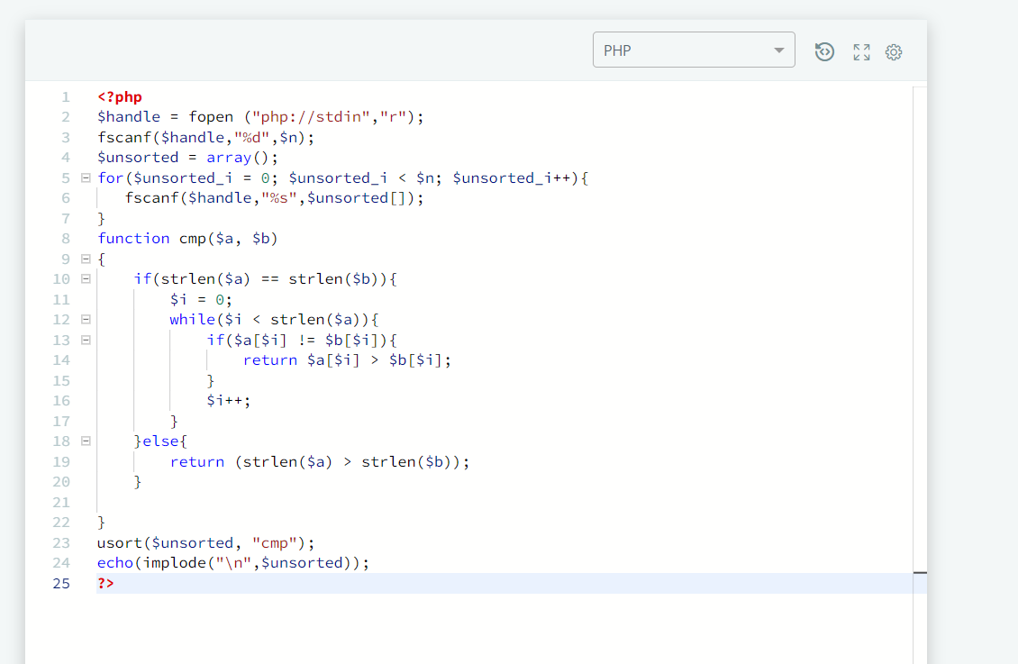  
  
17. Super Reduced String  
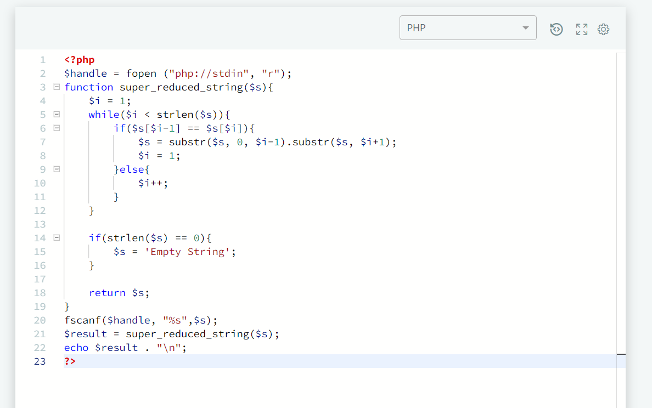  
  
  
  
  
  
  
18. Camel Case  
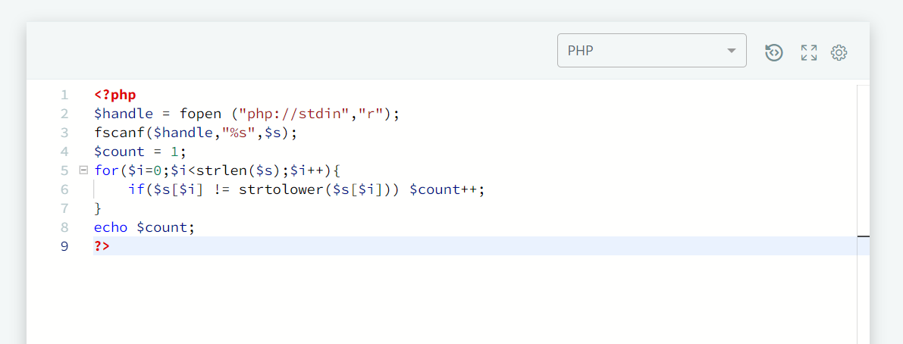  
  
19. Insertion Sort – Part 1  
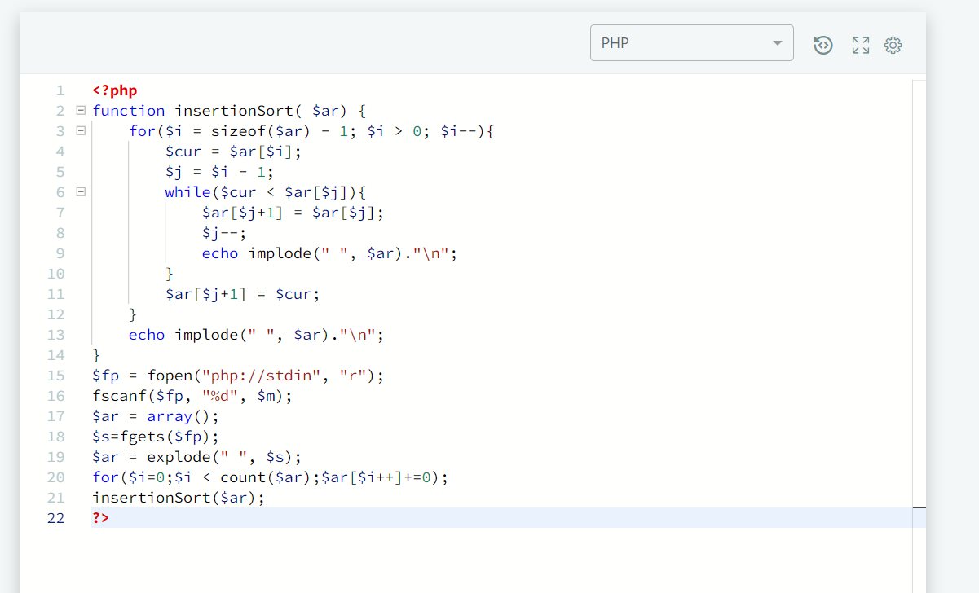

20. Two Characters  
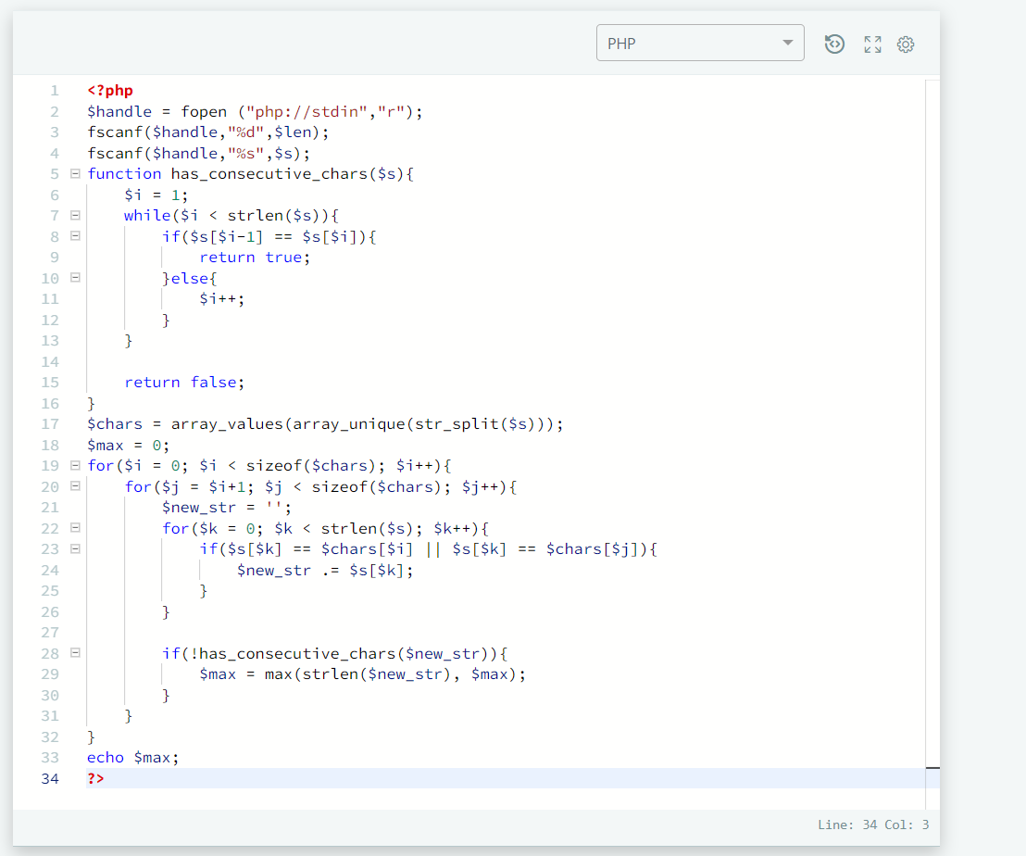  
  
21. Caesar Cipher  
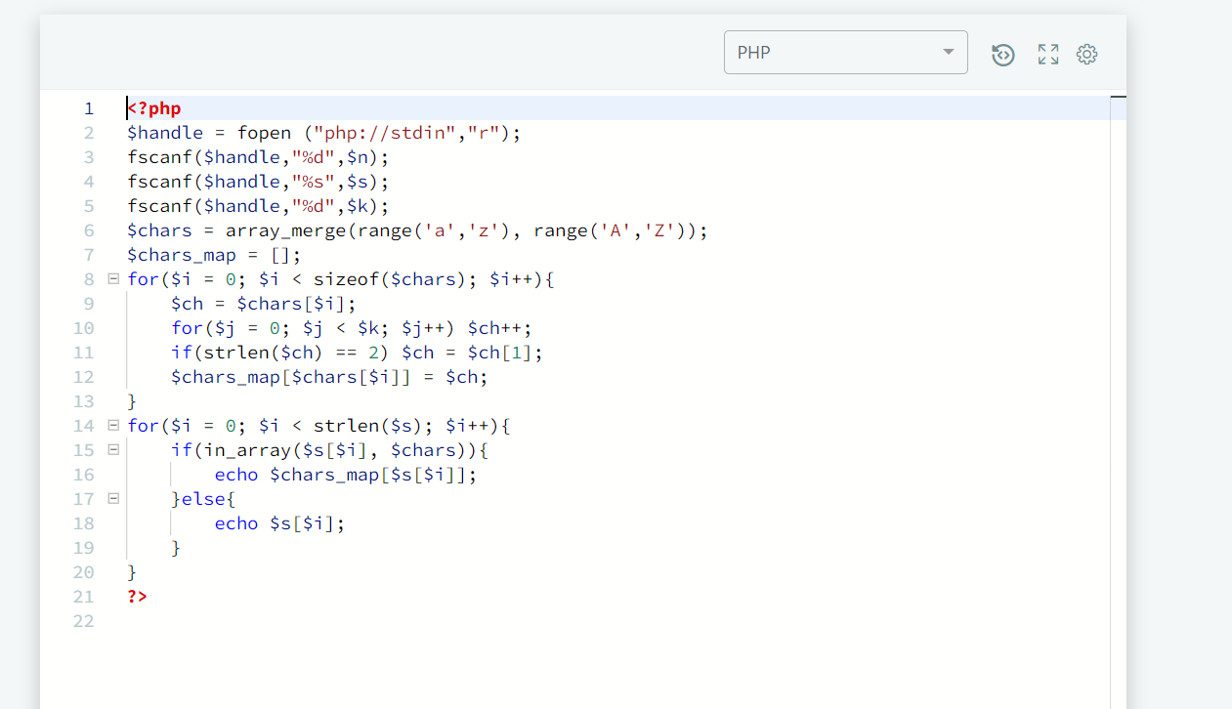

22. Mars Exploration  
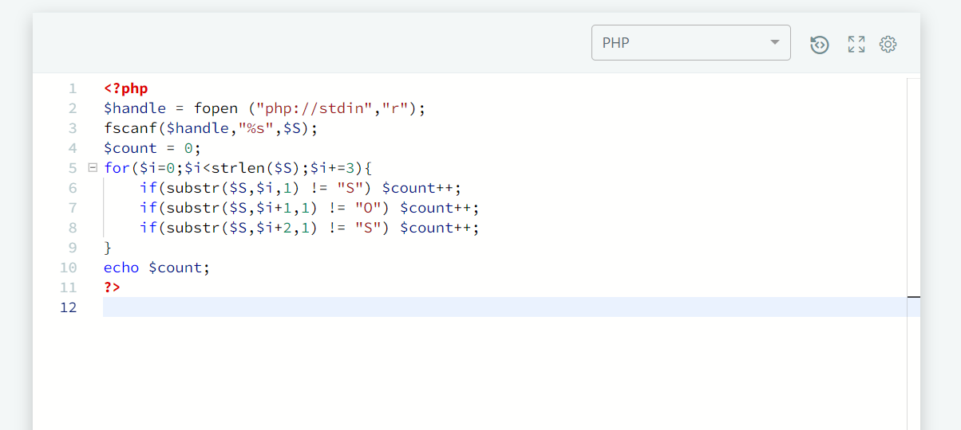

23. Pangrams  
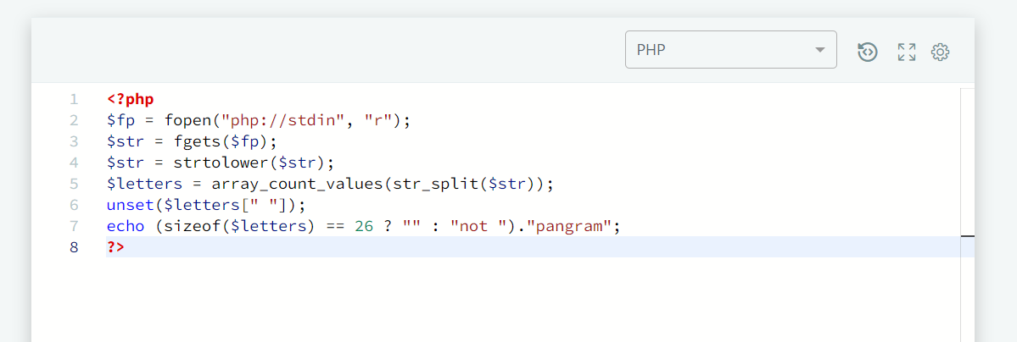  
  
24.Counting Sort 1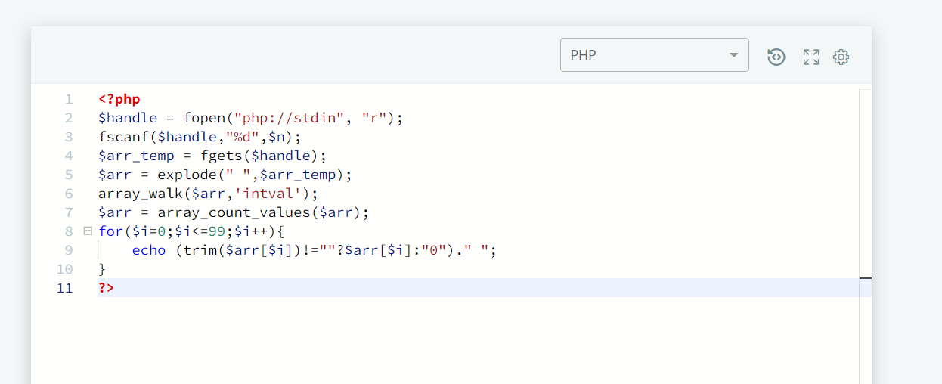

25. Two Strings  
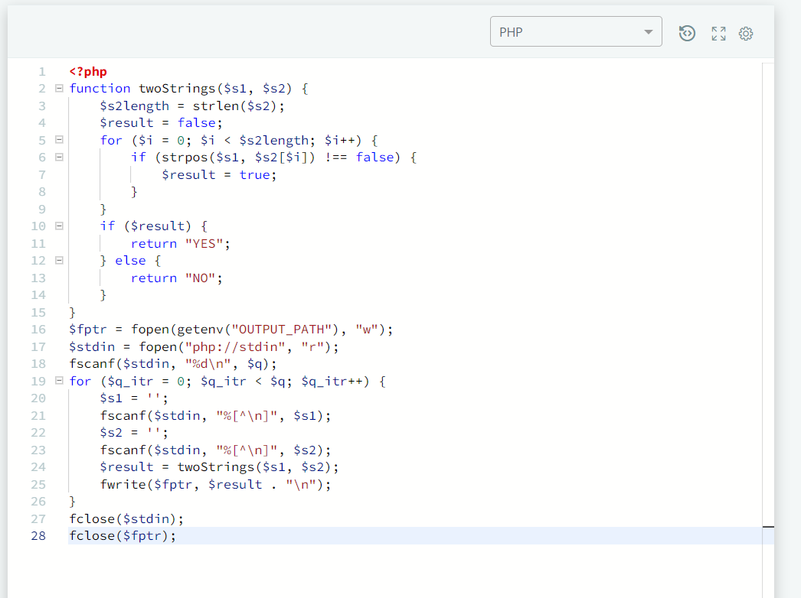  
  
26. String Construction  
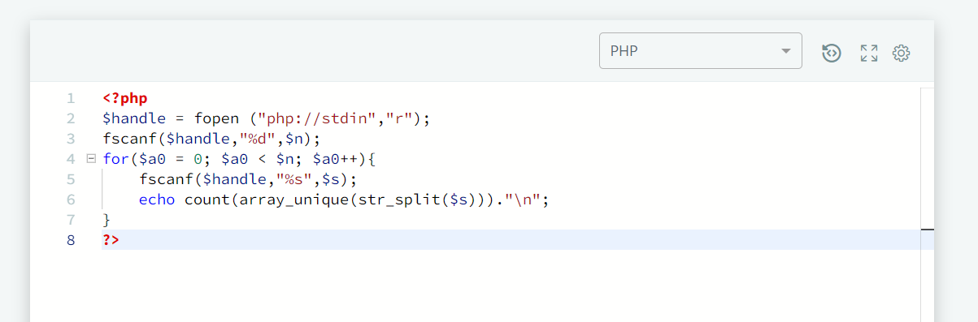

27. Ice Cream Parlor  
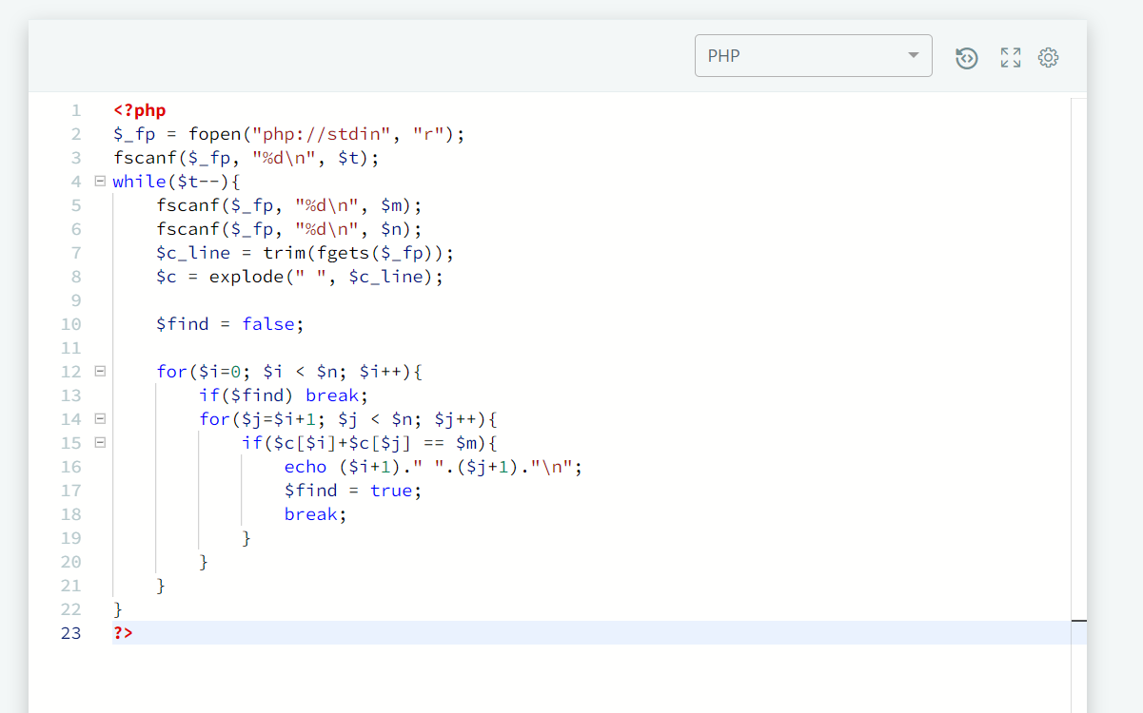  
  
28. Profil  
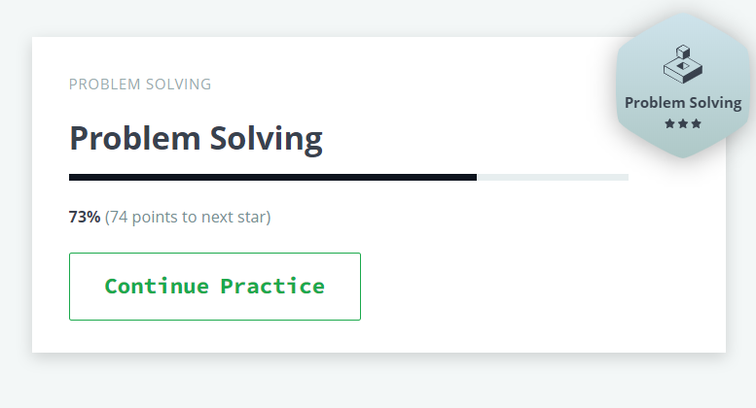  
  
  
  
  
  
  
  
29. Submission  
